SIMATS ENGINEERING
ASSESSMENT TOOL 1 - Medium
Coding Challenge

COURSE CODE: ITA04 COURSE NAME: Statistics with R Programming

COURSE OUTCOME COVERED

CO2: Analyze datasets using Exploratory Data Analysis techniques including measures of central tendency, dispersion, bivariate analysis, and statistical tests such as T-test, ANOVA, and chi-square. (BL4-BL5)

Assessment Tool Weightage: 25%

QUESTIONS: 5 Total Marks: 50

Coding Challenge

Code of Conduct:

I Bhuvaneshwari B A (192421195)(Name / Reg No) certify that this submission is my original work and that I have adhered to the guidelines specified for this assessment.
I understand that any violation of academic integrity rules will result in disciplinary action.

Signature of the student:

BHUVANESHWARI B A

Coding Challenge

- Write an R program to declare variables of each basic data type (numeric, integer, character, logical, complex) and print their class using class().
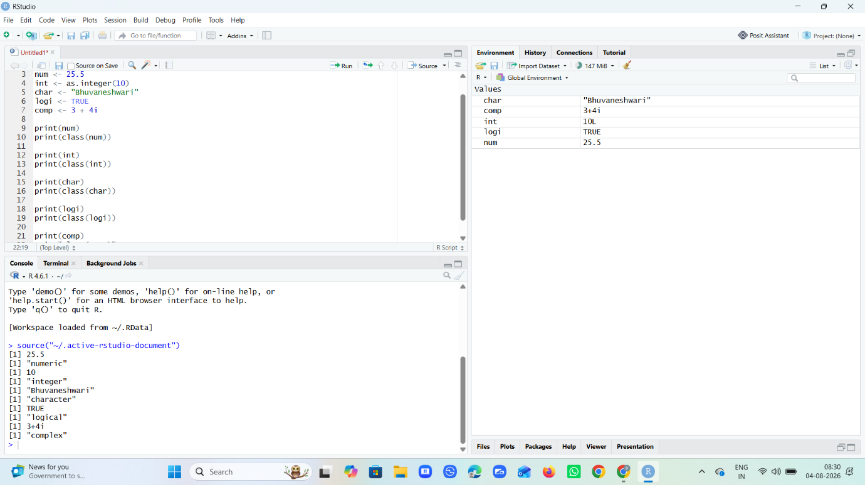
- Write an R program using a for loop to print the Fibonacci series up to n
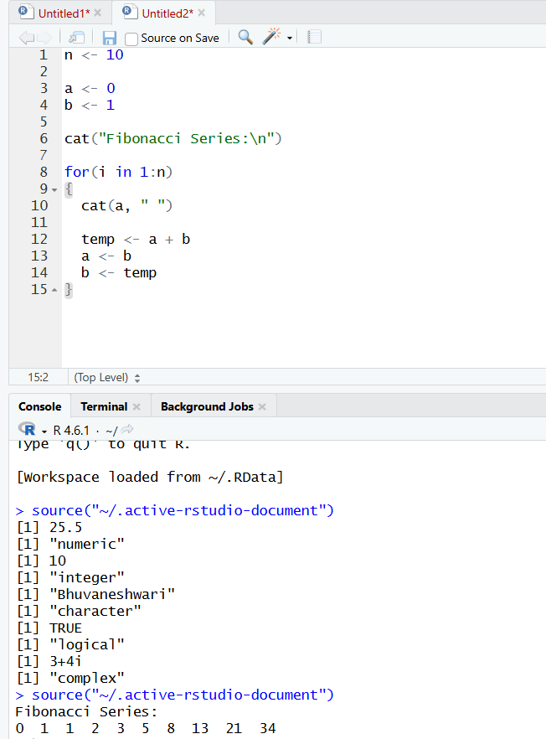

3.Create a data frame with columns StudentID, Name, Marks, and Grade for 10
students. Write a program to add a new column Result based on a condition
on Marks.
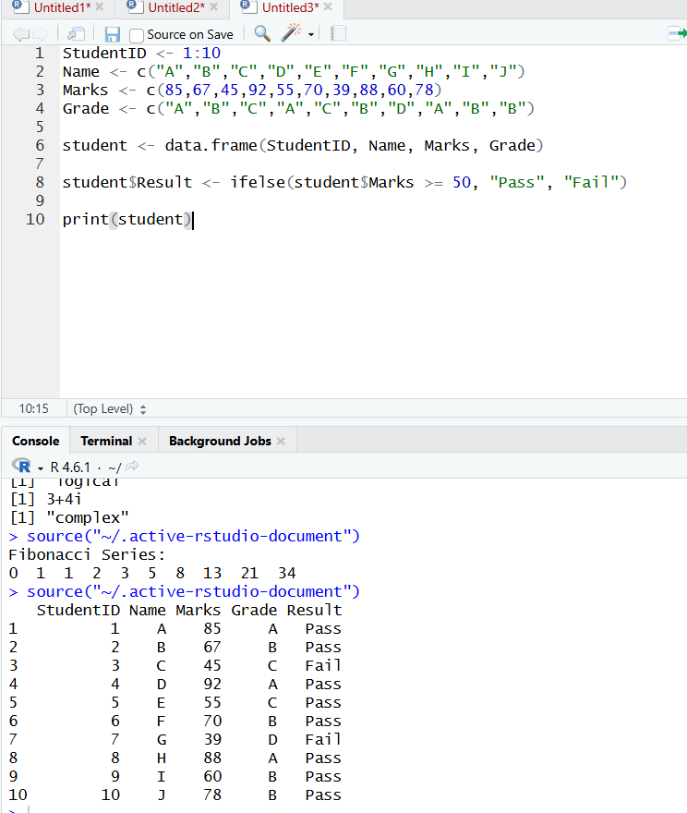
4. Write a program to create two logical vectors and demonstrate AND, OR,
NOT, and XOR operations on them element-wise.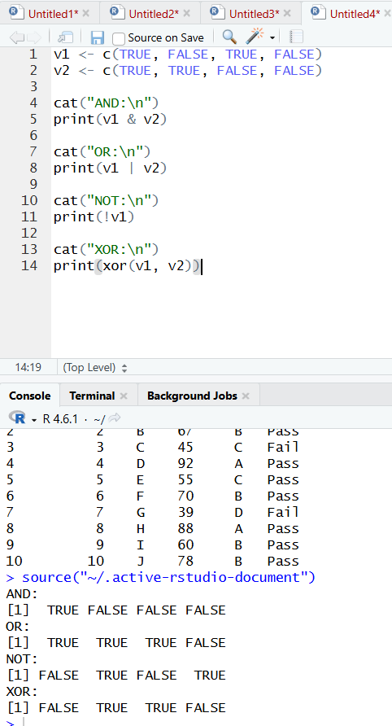

5.Write a program to implement a simple calculator using a function with
arguments for two numbers and an operator (+, -, *, /), using if-else control
statements.
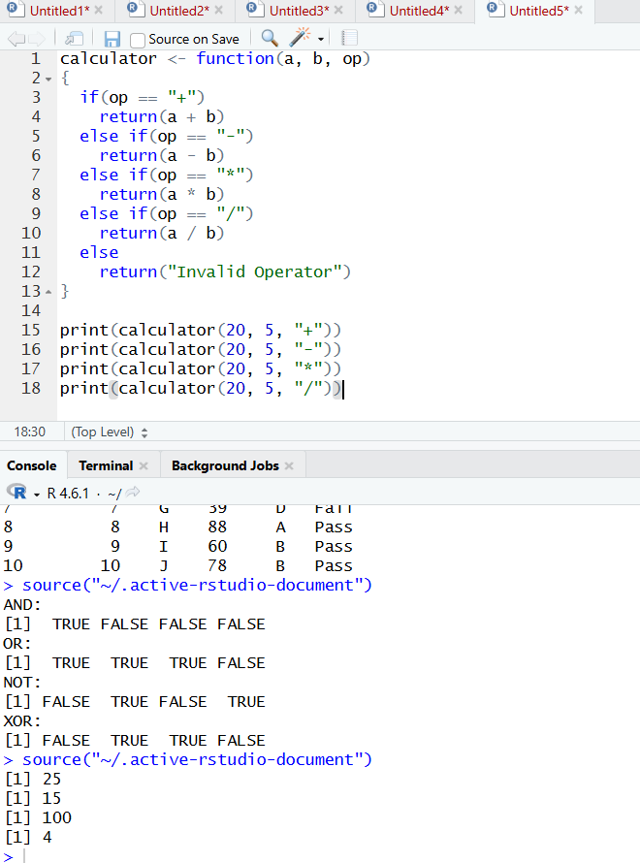

RUBRICS FOR CALCULATION

Criteria | Weightage | Level 4 (Excellent) | Level 3 (Good) | Level 2 (Satisfactory) | Level 1 (Needs Improvement)
Data Preparation | 15% | Dataset is correctly created/imported with no errors. | Dataset is mostly correct with minor errors. | Dataset contains some inaccuracies affecting calculations. | Dataset is incorrect or incomplete.
Calculation Accuracy | 35% | All statistical measures/calculations are correct and accurately interpreted. | Most calculations are correct with minor errors. | Several calculation errors present. | Major errors; calculations are incorrect or missing.
Use of R Functions | 20% | Appropriate R functions are selected and used efficiently. | Functions are mostly appropriate with minor issues. | Limited or partially correct use of functions. | Incorrect or no use of relevant R functions.
Analysis and Interpretation | 20% | Results are clearly interpreted with logical conclusions. | Interpretation is mostly correct with minor gaps. | Limited interpretation of results. | No meaningful interpretation provided.
Presentation of Results | 10% | Output is clearly organized, labeled, and documented. | Output is organized with minor formatting issues. | Output lacks clarity or proper labeling. | Output is poorly presented or incomplete.

